**Name :- Malik Arfat Hassan**

**Reg No:- SP22-BSE-024**

**Assignment No: 03**

**Date: 10/12/2024**

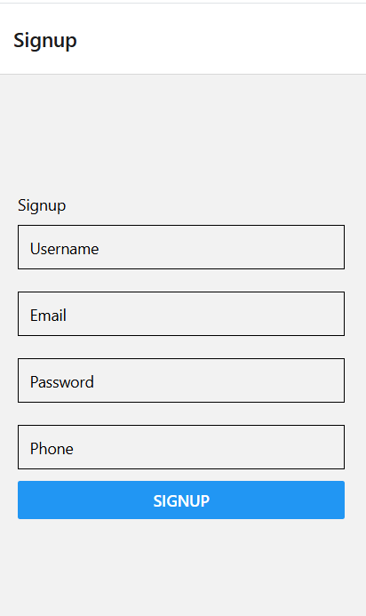

**Code:**

import React, { useState } from 'react';

import { View, TextInput, Button, Text, StyleSheet } from 'react-native';

export default function SignupScreen({ navigation }) {

  const [username, setUsername] = useState('');

  const [email, setEmail] = useState('');

  const [password, setPassword] = useState('');

  const [phone, setPhone] = useState('');

  const validateForm = () => {

    const emailRegex = /^[^\s@]+@[^\s@]+\.[^\s@]+$/;

    const phoneRegex = /^\+92-3\d{2}-\d{7}$/;

    if (!username.match(/^[A-Za-z]+$/)) return alert('Username must contain alphabets only.');

    if (!emailRegex.test(email)) return alert('Invalid email format.');

    if (password.length < 8) return alert('Password must be at least 8 characters.');

    if (!phoneRegex.test(phone)) return alert('Phone number must match +92-3xx-xxxxxxx format.');

    navigation.navigate('Login');

  };

  return (

    <View style={styles.container}>

      <Text>Signup</Text>

      <TextInput placeholder="Username" value={username} onChangeText={setUsername} style={styles.input} />

      <TextInput placeholder="Email" value={email} onChangeText={setEmail} style={styles.input} keyboardType="email-address" />

      <TextInput placeholder="Password" value={password} onChangeText={setPassword} style={styles.input} secureTextEntry />

      <TextInput placeholder="Phone" value={phone} onChangeText={setPhone} style={styles.input} keyboardType="phone-pad" />

      <Button title="Signup" onPress={validateForm} />

    </View>

  );

}

const styles = StyleSheet.create({

  container: { flex: 1, justifyContent: 'center', padding: 20 },

  input: { borderWidth: 1, padding: 10, marginVertical: 10 },

});

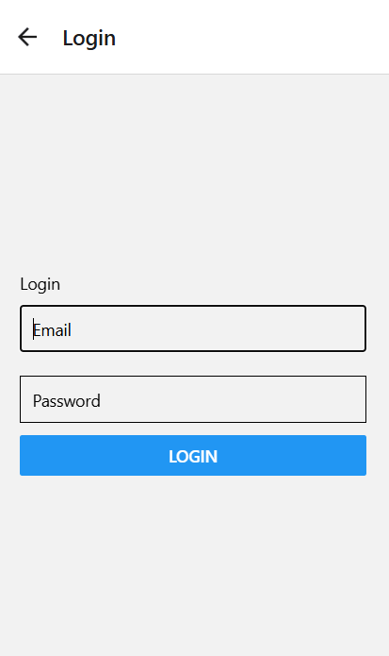

**Code:**

import React, { useState } from 'react';

import { View, TextInput, Button, Text, StyleSheet } from 'react-native';

export default function LoginScreen({ navigation }) {

  const [email, setEmail] = useState('');

  const [password, setPassword] = useState('');

  const handleLogin = () => {

    if (!email || !password) return alert('All fields are required.');

    navigation.navigate('ThirdScreen');

  };

  return (

    <View style={styles.container}>

      <Text>Login</Text>

      <TextInput placeholder="Email" value={email} onChangeText={setEmail} style={styles.input} keyboardType="email-address" />

      <TextInput placeholder="Password" value={password} onChangeText={setPassword} style={styles.input} secureTextEntry />

      <Button title="Login" onPress={handleLogin} />

    </View>

  );

}

const styles = StyleSheet.create({

  container: { flex: 1, justifyContent: 'center', padding: 20 },

  input: { borderWidth: 1, padding: 10, marginVertical: 10 },

});

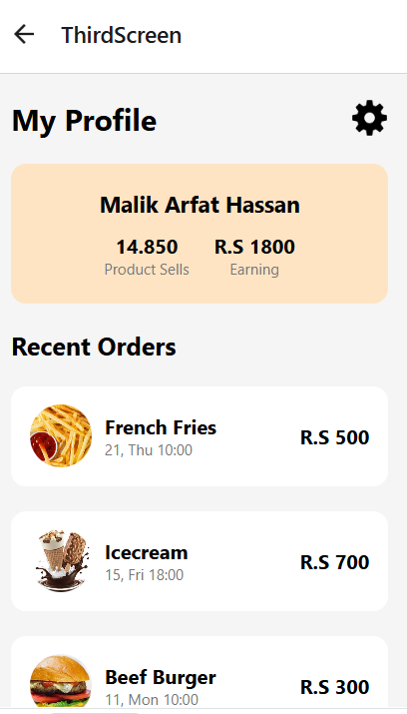

**Code:**

import React from 'react';

import { View, Text, Image, StyleSheet, ScrollView } from 'react-native';

const ProfileScreen = () => {

  return (

    <ScrollView style={styles.container}>

      {*/* Profile Header */*}

      <View style={styles.profileHeader}>

        <Text style={styles.profileTitle}>My Profile</Text>

        <Image

          source={{ uri: 'https://img.icons8.com/ios-filled/50/000000/settings.png' }}

          style={styles.settingsIcon}

        />

      </View>

      {*/* User Info */*}

      <View style={styles.userInfo}>

        <Text style={styles.userName}>Malik Arfat Hassan</Text>

        <View style={styles.userStats}>

          <View style={styles.statBox}>

            <Text style={styles.statValue}>14.850</Text>

            <Text style={styles.statLabel}>Product Sells</Text>

          </View>

          <View style={styles.statBox}>

            <Text style={styles.statValue}>R.S 1800</Text>

            <Text style={styles.statLabel}>Earning</Text>

          </View>

        </View>

      </View>

      {*/* Recent Orders */*}

      <Text style={styles.recentOrdersTitle}>Recent Orders</Text>

      <View style={styles.orderList}>

        {orderData.map((order, index) => (

          <View key={index} style={styles.orderCard}>

            <Image source={{ uri: order.image }} style={styles.orderImage} />

            <View style={styles.orderDetails}>

              <Text style={styles.orderTitle}>{order.title}</Text>

              <Text style={styles.orderDate}>{order.date}</Text>

            </View>

            <Text style={styles.orderPrice}>{order.price}</Text>

          </View>

        ))}

      </View>

    </ScrollView>

  );

};

*// Sample data for orders*

const orderData = [

  {

    image: 'https://encrypted-tbn0.gstatic.com/images?q=tbn:ANd9GcRJV1RVOmJGwrWjio1p4M40W-ijLmZiVS0Swg&s',

    title: 'French Fries',

    date: '21, Thu 10:00',

    price: 'R.S 500',

  },

  {

    image: 'https://encrypted-tbn0.gstatic.com/images?q=tbn:ANd9GcRFkrQJD5kWtJmYQjURG_zlDC_GqWLMSAzsSA&s',

    title: 'Icecream',

    date: '15, Fri 18:00',

    price: 'R.S 700',

  },

  {

    image: 'https://encrypted-tbn0.gstatic.com/images?q=tbn:ANd9GcT59siP2RQ0_tArSBYwc9qZeOP9ctZg67Hg1w&s',

    title: 'Beef Burger',

    date: '11, Mon 10:00',

    price: 'R.S 300',

  },

];

const styles = StyleSheet.create({

  container: {

    flex: 1,

    backgroundColor: '#F5F5F5',

    paddingHorizontal: 16,

  },

  profileHeader: {

    flexDirection: 'row',

    justifyContent: 'space-between',

    marginVertical: 20,

  },

  profileTitle: {

    fontSize: 24,

    fontWeight: 'bold',

  },

  settingsIcon: {

    width: 30,

    height: 30,

  },

  userInfo: {

    backgroundColor: '#FFE4C4',

    borderRadius: 12,

    padding: 20,

    alignItems: 'center',

  },

  userName: {

    fontSize: 18,

    fontWeight: 'bold',

  },

  userStats: {

    flexDirection: 'row',

    marginTop: 10,

    justifyContent: 'space-between',

  },

  statBox: {

    marginHorizontal: 10,

    alignItems: 'center',

  },

  statValue: {

    fontSize: 16,

    fontWeight: 'bold',

  },

  statLabel: {

    fontSize: 12,

    color: '#777',

  },

  recentOrdersTitle: {

    marginTop: 20,

    fontSize: 20,

    fontWeight: 'bold',

  },

  orderList: {

    marginTop: 10,

  },

  orderCard: {

    flexDirection: 'row',

    backgroundColor: '#FFF',

    borderRadius: 12,

    padding: 15,

    marginVertical: 10,

    alignItems: 'center',

    justifyContent: 'space-between',

  },

  orderImage: {

    width: 50,

    height: 50,

    borderRadius: 25,

  },

  orderDetails: {

    flex: 1,

    marginLeft: 10,

  },

  orderTitle: {

    fontSize: 16,

    fontWeight: 'bold',

  },

  orderDate: {

    fontSize: 12,

    color: '#777',

  },

  orderPrice: {

    fontSize: 16,

    fontWeight: 'bold',

  },

});

export default ProfileScreen;

**Expo Link:**

https://snack.expo.dev/@malikarfat12/e5eb84